SUSHIL MAYEKAR

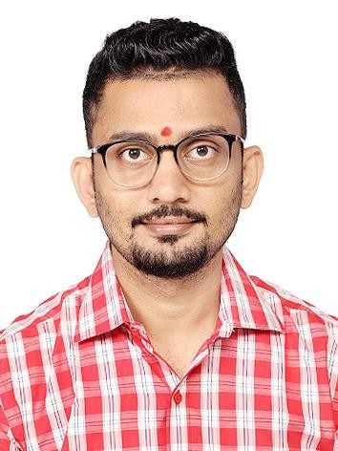

Room No.2, Sharma Niwas Chawl, Bhandup (W)-Mumbai-400078 Mobile No.: 8450950806

Contact by email : [sushilmayekar69@rediffmail.com](mailto:sushilmayekar69@rediffmail.com)

[sushilmayekar09@gmail.com](mailto:sushilmayekar09@gmail.com)

**Carreer Objective**

I seek challenging opportunities where I can fully use my skills for the success of the organization.

I want to excel in this field with hard work, perseverance and dedication.

# Professional Overview

A proactive and skilled individual with over 6 years of experience in:

* Operations – Processing Documents, Maintain Data, TAT Reports, Quality Check (Checker and Maker), KYC, Co- ordinate with vendor, Handling Mail.
* MIS Reporting.
* Collation of Data, Data Maintain and updation.
* Worked on Application: CRM, OMS Application, DMS, Cordis, Omni Docs, I-Disburse, Catalyst Software.

# Work Experience

## Boston Ivy Healthcare Solutions Private Limited (Feb 2022 – May 2023) Executive.

Worked as Executive for Catalog Management, Maintaining and updting data on system.

**Responsibilities:**

* + Prepare Sheet Creation and Quality check Images of Healthcare Product.
  + Preparing MIS Report Daily Basis. - Product Wise, Remark Wise, Zone Wise Report Prepared. Rejection Report & Transaction Report Prepared.
  + Find out Product Features and Specification with the help of Internet.
  + Follow up with Other Team for Query Resolve.
  + Images and Sheet upload in Catalyst Software.
  + Prepare Performance report on Daily, Monthly, Weekly.
  + Handling Email and coordinate with Other Team Members.
  + Query resolve of Other Team regarding Excel.
  + Provide Training to the New Joiners.

## SR Consultancy (Nov 2019 – Jan 2022)

**MIS Executive.**

**Responsibilities:**

* + Prepare Report on Daily basis.
  + Follow-up with sales Team for data schedule.
  + Quality Check.
  + Prepare Performance report on daily basis.
  + Prepare Weekly, Monthly, Quarterly, Half Yearly & Yearly Business MIS & Analysis.
  + Prepare MIS reports required by management for business studies.
  + Prepare the Schedule Monthly, Weekly, Daily.

## ICICI BANK LTD (Sep 2016 – Oct 2019)

**Team Leader - MIS**

**Responsibilities:**

* + Prepare dashboard for pending sampled & screen report.
  + Analysis of the data for seeding & mystery shopping cases and prepare the dashboard as per senior’s requirement.
  + TAT Hours MIS prepare and dashboard published & Collation of data.
  + Co-ordinate with Manger / Regional Manager and prepare the dashboard as per requirements.
  + Prepare dashboard for Hunter report cases & Prepare Dashboard Rank wise.
  + Knowledge of Vlookup, Remove Duplicate, IF AND, prepare of Dashboard, count if, text, TAT calculation.
  + Dashboard and dump send to Branch.

## Cholamandalam MS General Insurance Co Ltd (Mar 2014 – May 2016) Customer Service Officer.

Worked as Executive for Operation, Maintaining and updating data on system. MIS.

**Responsibilities:**

* + Smooth functioning of daily branch operations & Quality Checking.
  + Create the Customer ID and update the PTS (Policy Tracking System)
  + Update QC Dispatched Proposal & Upload the Document in the DMS
  + Resolve the Rejection in DMS & Cordys.
  + Uploaded endorsement in Cordys and Resolve the Rejection.
  + Daily preparing Reports of MIS and data provided to Branch
  + Maintain Cover Note Tracker & E Policy Issuing, Follow-up with Branches for Resolving the Rejections, Cover Note and Back papers dispatched to HO.
  + Attending and reverting Inward & Outward mails relating to E Policies
  + Coordination with Branch Operations
  + Resolve the query of Branches and customers.

## LIC of India (Aug 2011 – Feb 2014)

Worked as LIC agent.

**Responsibilities:**

* + Collect Documents, Explain Benefits, coverage to Customer. Payment follow up. paid Customer Premium to LIC Branch.

## Achievement:

* + Appreciated by seniors to working ability and always got an increment in job profile as well as in responsibilities.

## Academic Background

A Commerce Graduate from Mumbai University (2010).

# IT Skills

* Well versed in MS Office.
* Excellent Command over MS Excel (Formula, Pivot, Count if, VLOOKUP, Index Match etc.).
* MSCIT
* English Typing 30wpm.

# Personal Details

Father’s Name : Sudhir Mayekar.

Date of Birth : 27th Sept 1987

Gender : Male

Nationality : Indian

Religion : Hindu-Bhandari

Marital Status : Married

Languages Known : Hindi, English & Marathi Hobbies : Playing Cricket, Watch Movie.

# Declaration

I here by declare that the statements made above are true, complete and correct to the best of my knowledge and belief.

Date: **- -**

Place: Mumbai



(SUSHIL SUDHIR MAYEKAR.)